***Individual contributions:***

Area highlighted in red represent part of level member worked on

Each area contains at least one weapon and spawn point

Alex:

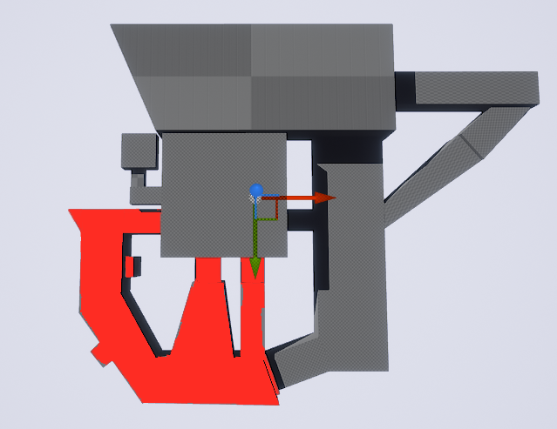

River: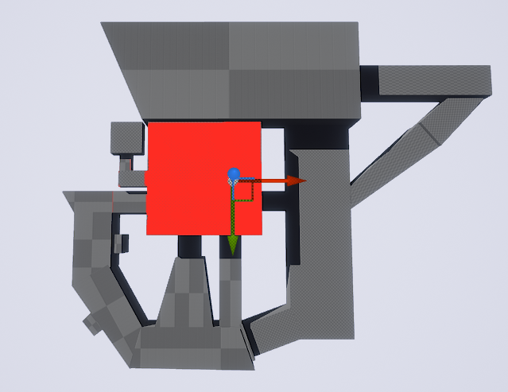

Michael:

